Introduction
Historic places are often seen as inherently inaccessible. While this is untrue in many ways, this attitude has led to a lack of access measures being implemented at historic places.
This guide, produced by Heritage BC on behalf of the Heritage Branch of the Province of British Columbia, seeks to arm the owners and managers of historic places with the tools to successfully enhance the accessibility of those places for persons with disabilities without damaging the heritage values and character-defining elements.
First the legal and social context will be established, followed by the process of planning for and implementing accessibility. Finally, the guide will look at common barriers to accessibility at historic places and will provide tips to eliminate these barriers.

Legal and Social Context

United Nations Convention on the Rights of Persons with Disabilities
The UN Convention on the Rights of Persons with Disabilities (CRPD), to which Canada is a signatory, is based on what is called ‘the social model of disability’. The social model states that society and the barriers it creates are what disables people, not the body. Therefore, it is the responsibility of society to eliminate barriers to access, not the responsibility of the individual to adapt their body to society. This model is the basis of not only the CRPD, but also the laws and codes discussed below, and the principles of this guide.
While the CRPD does not specifically mention heritage or historic places, it does state that persons with disabilities have the right to fully participate in society, arts and culture, which includes accessing, using and enjoying historic places.

Human Rights Legislation in Canada
Human rights legislation at both the federal and provincial levels in Canada follow the same theory and model as the CRPD. Heritage or historic places are not specifically mentioned, but all Canadians with disabilities have a right to fully participate in society and receive services equally with able-bodied Canadians.

BC Building Code
The BC Building Code (BCBC) uses both the social model and the principle of barrier free design. Barrier free design, which is also known as universal design or design for all, advocates that a building, feature or product should be designed so that it may be used by as wide a segment of the population as possible. For example, an entrance to a building that is well lit, level to the pavement, marked with tactile flooring, and uses powered doors that can also be pushed open would be barrier free. Municipalities that have their own building codes, such as Vancouver, generally follow the same principle.
While the BCBC does not currently take into account the unique needs of historic places, it does provide benchmarks for access features and measures. It also may come into force depending on the scope of the project being undertaken. Always check with the local government or regional district before starting an access project that will alter building fabric or create new features.
The Building Access Handbook 2014 provides commentary and diagrams on the access requirements of the BCBC. Like the BCBC, it makes no mention of historic places and can be quite technical. However, it is an excellent resource on access requirements and possible configurations of, for example, washrooms or stairwells.
All measurements in this accessibility guide and the appended checklist come from the handbook.

Creating Accessibility

Planning Process
When undertaking accessibility improvement projects, the first step should always be planning. This is particularly important for historic places.
Conservation planning and accessibility planning should be done in combination to ensure interventions are completed efficiently while not altering character-defining elements. For example, when performing maintenance on a verandah, a ramp can be added in compatible materials such as the same wood painted to the same colour scheme as the verandah.
The flow chart on page 4 shows this planning process. Each step will be discussed below.

Statement of Significance and Conservation Plan
A Statement of Significance (SoS) is a brief document that describes a historic place, the values it represents, and the character-defining elements that embody those values (more information on writing a SoS can be found at https://www2.gov.bc.ca/gov/content/governments/celebrating-british-columbia/historic-places/provincial-federal-registers). This document is important to planning because it lists the elements that give the place value and therefore cannot be altered to create access without damaging the heritage values of the historic place.
The Conservation Plan is a detailed document that evaluates the current condition of a historic place and provides an in-depth plan and recommendations for conserving the site over a certain number of years. Usually these recommendations are focused on the conservation of character-defining elements.
The SoS and Conservation Plan should be in place and recently updated before the access audit and accessibility measures are undertaken.

Access Audit
The access audit evaluates the entire historic place, using a checklist such as the one provided in the appendix. This includes travel to and from the site, grounds and pathways, entrances and doors, horizontal and vertical movement, and facilities such as washrooms. Other considerations include information such as signs and the means of escape in case of an emergency.
The audit will take into account all types of disabilities: ambulant (persons with mobility impairments who do not use a wheelchair), non-ambulant (persons who use a wheelchair), vision, auditory, dexterity and cognitive.
The process will also identify what is currently accessible and where improvements could be made. It is at this point that persons with disabilities should be brought into the process. Most municipalities or regions have disability resource centres or similar organizations that can provide insight into the experiences of persons with disabilities accessing the historic place in question.

Access Plan
The access plan combines the recommendations of the conservation plan and access audit into a detailed document providing concrete steps to improve access over a specified period of time. These steps should detail how invasive the proposed measure is, its effect on character-defining elements, if any, and the possible materials or equipment that could be used.
It is important to remember that well-designed measures that use compatible materials sympathetic to the site will be the most successful and have the smallest impact on the heritage value of the historic place. The plan will also include a projected budget for the proposed measures when included in ongoing conservation efforts.
Before it is finalized, the access plan should be reviewed by persons with disabilities.

Implementation and Review
Accessibility should frequently be reviewed, as technological innovations can create access that was previously thought impossible or unaffordable.
Maintenance of access features is also very important, as a poorly maintained access feature can become a barrier. For example, crumbling concrete can pose a trip hazard or cause a wheelchair to become stuck on a path or ramp. Keeping features free of debris and obstacles, such as snow or furniture, is also imperative.
Persons with disabilities should also be consulted on a recurring basis. They can provide feedback as measures are implemented.
It is also important to remember that all people with disabilities are different and experience barriers to access differently. Every individual can provide new insight or new ideas for improving access. It is important to keep in mind everyone has the right to say ‘no’ to providing feedback. Do not solicit feedback in such a way that singles out an individual specifically because of their disability. Instead utilize disability resource centres and similar groups, or solicit the same feedback from all visitors.
Write Access Plan
Review, evaluate and consult
Implement access measures and conservation projects
Determine conservation and access priorities and budget over 5 to 10 year period
Consult with people with disabilities, heritage professionals and local government
Conduct Access Audit
Write Conservation Plan
Write Statement of Significance

Accessibility Measures
The following are common ways to increase access to historic places, with some BC examples provided.
It is important to understand that a measure that is compatible with one place will not be appropriate with another, so all measures should be undertaken with the character-defining elements of the specific historic place in mind.

Website
Evaluate websites with an accessibility checker such as wave.webaim.org. The online program will suggest changes that can be implemented.
Websites and social media pages can include detailed information on the accessibility of the historic place. This should include all types of access, not just wheelchair users. Keep this information up to date as access improvements are made.
Detailed, accurate information enables persons with disabilities to make decisions about their individual ability to visit a historic place and is therefore an important part of accessibility.
It is also important to remember that not all technology is accessible. In fact, the majority is inherently inaccessible. When looking at technology such as touchscreens or motion capture to improve access, look at the intended use of the technology (was it specifically designed by and for persons with disabilities?) and talk with persons with disabilities.
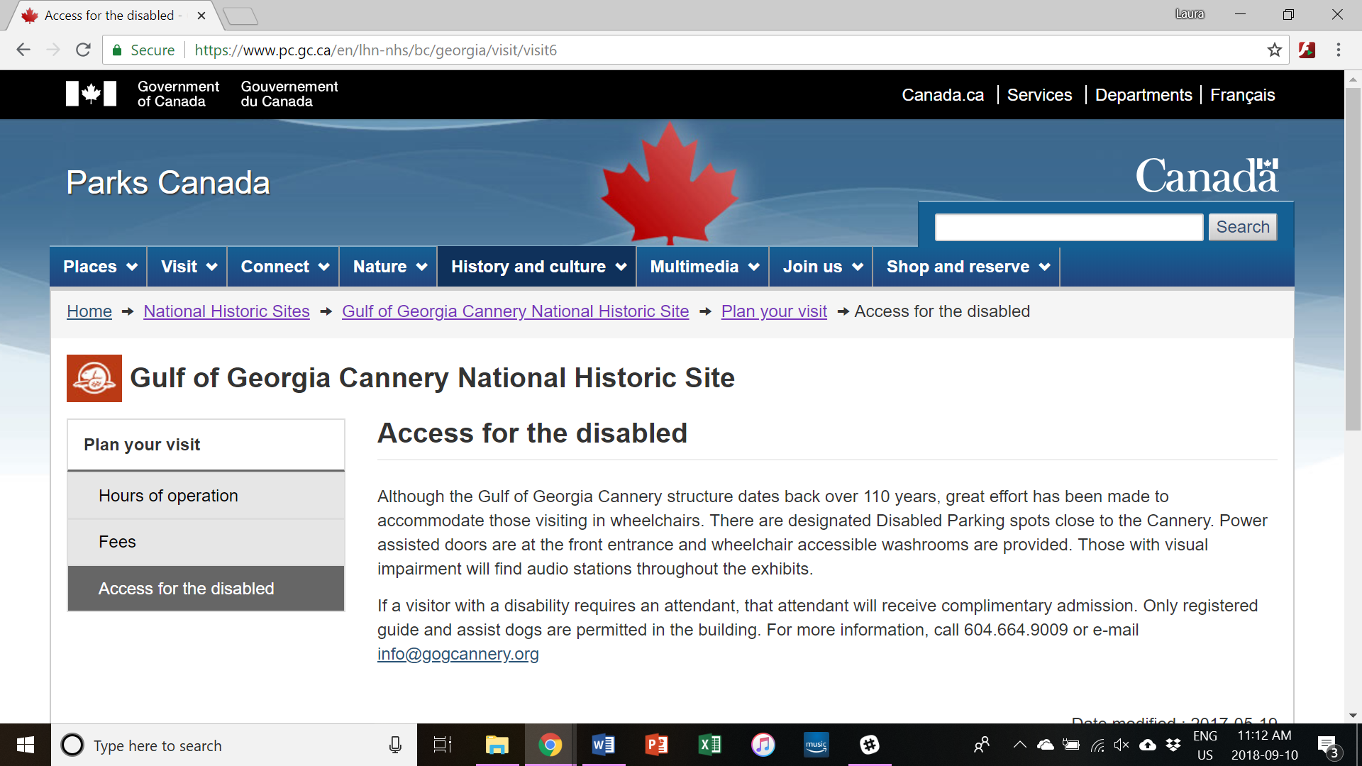
Figure 1: The Parks Canada website for the Gulf of Georgia Cannery National Historic Site includes detailed information on access to the site. https://www.pc.gc.ca/en/lhn-nhs/bc/georgia/visit/visit6

Staff Training
All staff should be trained on accessibility issues related to the historic place and appropriate ways to interact with guests with disabilities. This training should be renewed on an ongoing basis.
The emergency management plan for the historic place should also be part of training. Staff should know how to assist guests with disabilities in all types of emergencies. For example, staff should know if the alarm system is audible and visible and the location of refuge points for those dependant on elevator access.

Information
Wherever possible, large and raised text alternatives should be provided for any signage or pamphlets. Braille versions are also good, however not all people with vision impairments read Braille. Videos should have captions and, ideally, American Sign Language (ASL) translations, and audio recordings should have written versions.
ASL is the language of d/Deaf people in North America and should be treated as such. However, it is not the only sign language and not all d/Deaf and hard of hearing people know it, so it should never replace captions or written versions completely.
Induction and infrared loops can allow people who use certain hearing aid devices to tune into audio presentations and to use public phones or intercom devices. These are particularly important to performing arts venues, however as the loop needs to be fixed in place they can be invasive and inappropriate in certain settings.
Signs and information should be posted at heights that are easily read or touched from both standing and seated positions, and tactile plans or information (such as raised maps, models or touch tours) can be offered wherever possible. Style should be uniform, colour contrasting and as straightforward as possible.
Noise and light levels should be considered and sensory stimulation should be lowered without compromising access for those with vision or auditory impairments. If possible, regular ‘turned down’ events can be offered for those with cognitive disabilities who experience overstimulation. Complimentary noise cancelling headphones and sunglasses can be provided if compatible with the use of the place.

Parking
According to the BC Building Code, one accessible stall for every 100 should be provided. Ideally, even small sites should have one accessible stall. The stall should be as close to the accessible entrance as possible, level, smooth, at least 3.7m wide and clearly marked. It should also be kept free from misuse. However, keep in mind that many persons with disabilities are not visibly disabled. Do not question the use of an accessible stall when the vehicle in question has the appropriate tags.

Ramps and Lifts
Where possible, ramps should be provided. In order to minimize the impact, ramps should be well designed with materials that are compatible with the historic site.
Placement is also important. The principle of equal access requires that the main entrance should be accessible to all, however, for many historic places, the composition and placement of the main entrance is a character-defining element. A well-designed ramp in compatible materials should have little to no impact on an entrance, where sufficient space exists. Secondary entrances should only be used when a ramp or powered access to the main entrance is not possible, when it can be accessed without assistance and when it is within a short distance of the main street or accessible parking. Temporary ramps are not a solution and should only be used as an interim measure or in extraordinary cases.
A well-designed exterior lift can provide access to multi-storey historic places while having minimal impact on the character-defining elements or historic fabric. Placement is key and materials should be used to minimize impact while also making it clear that the lift is a modern addition.
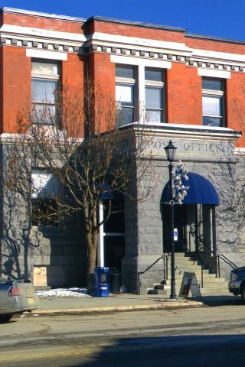
Figure 2: The Rossland Post Office uses glass and landscaping to successfully integrate its lift into the historic façade without compromising character defining elements or conservation principles. http://www.rossland.ca/post-office-0
Figure 3: St. Andrew's Roman Catholic Cathedral in Victoria uses ramps at its View Street entrances to provide access to both levels of the church. These entrances are around the corner from the main entrance on Blanshard Street. https://www.google.ca/maps/@48.4252317,-123.3630216

Stairs
Remember that ramps, while improving accessibility for some, can be inaccessible to others. Therefore, stairs and ramps should be provided in tandem.
Stair systems can be designed as a whole, but special considerations are required to ensure accessibility. Step risers should have a closed face and have a regular rise and depth. All nosings should be clearly visible and identified with tactile information, which is also required at both the top and bottom of the stairs.
Tactile information can be a change in flooring type that would feel different under foot, or it can be slip resistant paint or rubber strips applied to the existing flooring.
It is necessary to have variations in colours or shades, either by using different shades of the same colour or harmonizing colours.
Ideally, stairs should have a set of easily gripped handrails, although one side is acceptable. In stair systems with multiple flights, at least one handrail should be continuous.
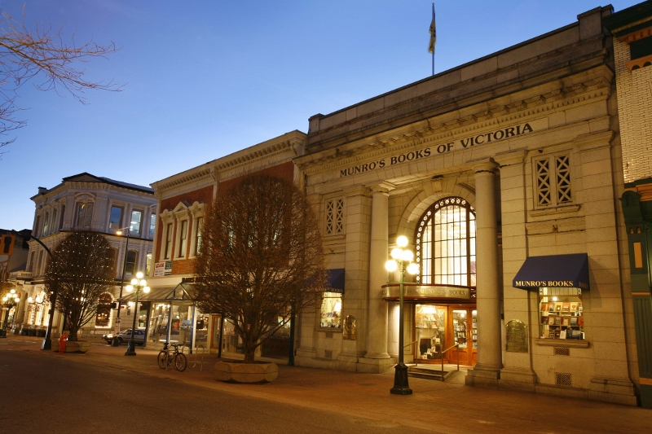
Figure 4: Munro's Books in Victoria (formerly the Royal Bank of Canada) seamlessly integrates ramps and stairs into its front entrance. https://www.munrobooks.com/?q=p.about_munro_s

Doors
Historic doors and hardware can be significant barriers to accessibility, particularly because changing historic hardware, moving primary entrances and widening doorways are generally inappropriate interventions.
Raised thresholds also pose a barrier to access, however they are often easier to deal with by either gradually raising the floor level approaching the threshold to be level with it, adding a small ramp up to the door, or by lowering the threshold. Similarly, doormats are a trip hazard that can also cause difficulties for a wheelchair user. However, this barrier can be removed by utilizing a recessed mat well or removing the mat entirely. If the mat is necessary and a recessed mat well inappropriate, the mat should have low pile and non-skid backing.
Door hardware is particularly challenging. Historic handles and locks can be an integral part of the historic fabric, but are often difficult to grip and operate. There is no universal solution, and every historic place will have to approach it differently.
When exploring solutions, the following questions considered: Is the hardware historic? Is it original? Does it match the era/style of the historic place? Is it a character-defining element? Can the hardware be changed to be accessible? Is it possible to leave the door open? Is it possible to add accessible hardware/convert the door to a different style while leaving historic hardware in situ?
While door hardware can poses challenges, there are many style options for accessible hardware and many would be appropriate for a historic place.
Finally, multiple handles on a single door could be inaccessible to people with cognitive disabilities who may struggle to intuitively operate the hardware. When implementing this solution, make sure that all hardware is functional.
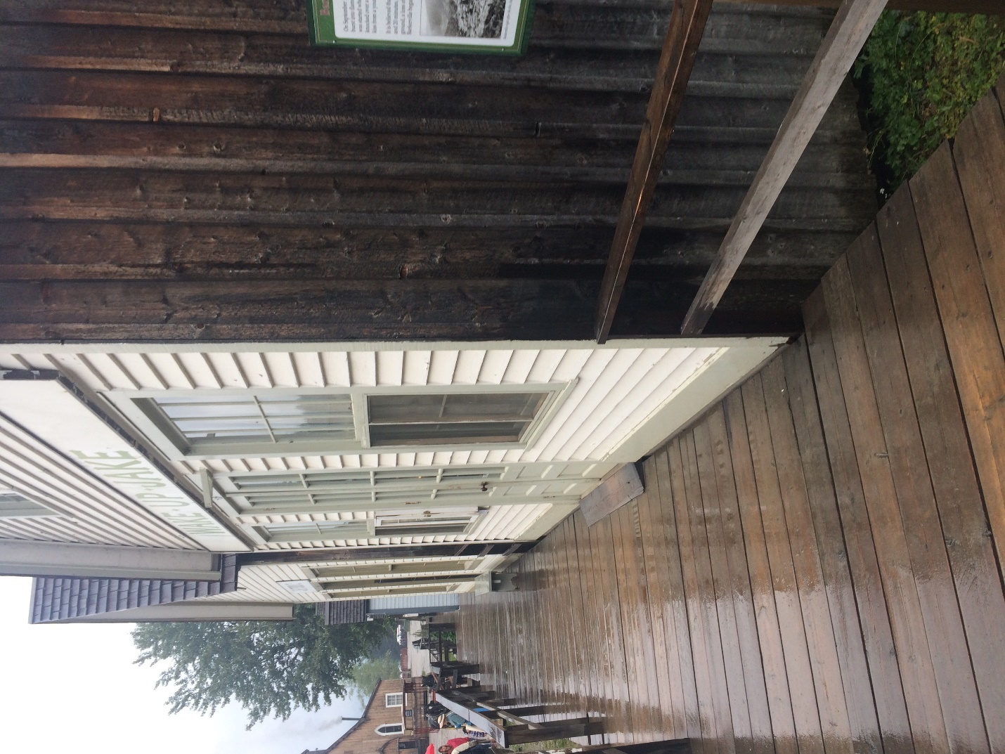
Figure 5: The Wake Up Jake Restaurant in Barkerville Historic Town and Park has a ramped threshold to provide access to wheelchair users and strollers. Author's photograph, 2018.

Facilities
Where public washrooms are provided, at least one stall should be made wheelchair accessible. Ideally, the washroom should be single stall and gender neutral, so that anyone who needs assistance from a carer or family member is able to use the washroom. If this provision is not possible, at least one accessible stall per washroom should be available. The accessible washroom or stall should be large enough to allow for wheelchair maneuvering, as well as front, side and lateral approaches to the toilet. Grab bars should be placed both to the side and above the toilet and toilet paper dispensers and waste containers should be placed within easy reach of someone seated on the toilet.
All washrooms and stalls should have slip resistant flooring that is readily distinguishable from the walls. All door handles, locks, taps and other fittings should be readily distinguishable and easy to grip and use for those with dexterity impairments. There should be at least one sink and soap dispenser no higher than 850mm from the ground with space underneath for wheelchair users of at least 250mm in depth.
The path to the washroom and the washroom itself must be free from potential obstacles and hazards.

Summary
It is always possible to improve access for persons with disabilities to historic places through careful evaluation, planning and consultation. Even something as simple and non-invasive as updating the website can make a difference. Physical interventions that are well designed, when undertaken with a clear understanding of the heritage values, character-defining elements and access needs of the historic place, will also make a significant impact on accessibility, but not on the place itself.
Access benefits everyone, and when done with understanding and consultation, it will also benefit historic places.

Other Sources
Historic England’s Easy Access to Historic Buildings https://historicengland.org.uk/images-books/publications/easy-access-to-historic-buildings/
Historic England’s Easy Access to Historic Landscapes https://historicengland.org.uk/images-books/publications/easy-access-historic-landscapes/
BC Building Access Handbook 2014 https://www2.gov.bc.ca/assets/gov/farming-natural-resources-and-industry/construction-industry/building-codes-and-standards/guides/2014_building_access_handbook.pdf
Center for Universal Design https://projects.ncsu.edu/design/cud/
US National Park Service’s “Preservation Brief 32: Making Historic Buildings Accessible” https://www.nps.gov/tps/how-to-preserve/briefs/32-accessibility.htm
Historic Scotland’s Managing Change in the Historic Environment: Accessibility https://www.historicenvironment.scot/archives-and-research/publications/publication/?publicationId=f0185b2c-3ed9-40c4-899d-a60b00885214
The Australian Heritage Council’s Improving Access to Heritage Buildings: A practical guide to meeting the needs of people with disabilities http://155.187.2.69/heritage/ahc/publications/commission/books/access-heritage-buildings.html
New Zealand Historic Places Trust Pouhere Taonga’s “Providing for Physical Access to Heritage Places” in its Sustainable Management of Historic Heritage Guidance http://www.heritage.org.nz/resources/sustainable-management-guides

Appendix
The following checklists are adapted from Penton, J (2008) Widening the Eye of the Needle: Access to Church Buildings for People with Disabilities 3rd ed. London: Church House Publishing.
All measurements are based on those used in the Building Access Handbook 2014: Illustrated Commentary on Access Requirements in the 2012 British Columbia Building Code.
Approach and car parking
Check/NA |  | Wheelchair | Ambulant | Dexterity | Visual | Auditory | Cognitive | Notes-use reverse as needed
 | Is the building within convenient walking distance of: a public highway?
 | -public transport?
 | -public parking?
 | Is the route clearly marked/found?
 | Is the route free of curbs?
 | Is the surface smooth and slip resistant?
 | Is the route wide enough, at no less than 1500mm?
 | Is it free of trip or impact hazards i.e. bins or outward opening windows?
 | Is the route adequately linked?
 | Is the route identified by visual, audible and tactile information?
 | Is there car parking for people with reduced mobility (min. 1 for every 100)?
 | Is it wide enough (3700mm), clearly marked out, signed, easily found and kept free from misuse?
 | Is it as near the entrance as possible?
 | Is it suitably surfaced?
 | Is the route to the building kept free of snow, ice and fallen leaves?
 | Is the route level, i.e. no gradient steeper than 1:20 and no steps?

Routes and external level change, including ramps and steps
Check/NA |  | Wheelchair | Ambulant | Dexterity | Visual | Auditory | Cognitive | Notes-use reverse as needed
 | Is there a ramp, with level surfaces at top/ intermediate/bottom?
 | Is it wide enough and suitably graded? Max 1:12 (can only be 6m long in this instance), 1:15 preferred
 | Is the surface slip resistant?
 | Are there curbs of no less than 75mm in height, and are their edges protected to prevent accidents?
 | Are there handrails to one or both sides?
 | If a permanent ramp cannot be formed, is a portable ramp available?
 | Are there alternative steps?
 | Identified by visual/tactile information?
 | Are there handrails to one or both sides?
 | Are ramps and steps adequately lit?
 | Are treads and risers consistent in depth and height?
 | Are all nosings marked and/or readily identifiable?
 | Are landings of adequate size (1500mm long preferred) provided at intermediate levels in long flights (every 9-12m)?
 | If safe and convenient steps and ramps cannot be provided is vertical movement by powered means an alternative?

Entrances, including reception
Check/NA |  | Wheelchair | Ambulant | Dexterity | Visual | Auditory | Cognitive | Notes-use reverse as needed
 | Is the door clearly distinguishable from the facade?
 | If glass, is it visible when closed?
 | Does the door opening or one leaf when opened permit passage of a wheelchair or double stroller?
 | Does it have a level or flush threshold, and a recessed mat well?
 | Is there visibility through the door/way from both sides at standing and seated levels?
 | On the opening side of the door is there sufficient space (300mm to the side and 1100mm to the front) to allow the door handle to be grasped and the door swung past a wheelchair footplate?
 | Can the door furniture be used at both standing and seated height?
 | Can it be easily grasped and operated?
If the door has a closure mechanism does it have:
-delayed closure action?
-slow action closure?
-minimal closure pressure?
 | If the door is power-operated does it have visual and tactile information?
 | If the door is security-protected, is the system suitable for use by people with sensory or mobility impairments?
 | If there is a lobby, do the inner and outer doors meet the same criteria?
 | Does the lobby layout enable all users to clear one door before passing through the next?
 | Are signs designed and positioned to inform those with visual impairments, and wheelchair users?
 | Does the lighting installation take into accounts the needs of people with visual impairments?
Are floor surfaces:
-slip resistant, even when wet?
-so hard that they cause acoustic confusion?
-firm for a wheelchair to manoeuvre?
 | Do junctions between floor surfaces present tripping hazards or cause visual confusion?
 | Is any reception point suitable for approach and use from both sides by people in standing and seated positions?
 | Is the reception point fitted with an induction loop for those who use hearing aids?
If a public phone is available, is it and its instructions:
-at a height suitable for all users?
-equipped with inductive couplings?
 | For those progressing to other parts of the building, is information provided by signs and supported by tactile information such as a map or model?

Horizontal movement and assembly
Check/NA |  | Wheelchair | Ambulant | Dexterity | Visual | Auditory | Cognitive | Notes-use reverse as needed
 | Is the corridor/ passageway/ aisle wide enough to manoeuvre and for people to pass?
 | Is any corridor etc. free from obstruction to wheelchair users and hazards to people with impaired vision?
 | Do any lobbies allow users to clear one door before approaching the next with minimal manoeuvre?
 | Is turning space available for wheelchair users?
 | Do natural and artificial lighting avoid glare and silhouetting?
 | Are there visual cues for orientation?
Do floor surfaces
-allow ease of movement for wheelchair users?
-avoid light reflection and sound reverberation?
 | Do textured surfaces convey useful information for people with impaired vision?
 | Are direction or information signs visible from both sitting and standing eye levels, are they in upper and lower case, and large enough type to be read by those with impaired vision?
 | Are there tactile signs and information for those with impaired vision?
 | Is the maintenance of these items checked regularly?
 | Is lighting designed to meet a wide range of needs?
 | Is sufficient circulation space allowed for wheelchair users?
 | Is it kept clear of obstructions which could create hazards for people with visual disabilities?
 | Are seating arrangements/ spaces available for use by people with disabilities?
 | Are all areas for assembly/ meeting equipped with an induction loop system?
 | If the use of an induction loop system is precluded, is an infra-red system available?
 | Is the functioning and operation of the induction loop or infra-red system checked regularly?
 | Are telephones fitted with inductive loop couplers?
 | Is a minicom available for use by people with hearing disabilities?

Vertical movement and internal level change
Check/NA |  | Wheelchair | Ambulant | Dexterity | Visual | Auditory | Cognitive | Notes-use reverse as needed
 | Is the location of any steps/ stairs/ ramp clearly indicated by use of sign/colour/ contrast/ texture/ lighting?
 | Does any step/ stairs/ ramp have a handrail to one/both sides and does it extend 300mm beyond the top and bottom of any flight?
 | Is any level change clearly lit?
 | Is the pitch (risers and treads) of steps/stairs or any ramp consistent and are nosings clearly identifiable?
 | If there are landings are they large enough to permit passing and turning manoeuvres, and are they provided in any long flight?
 | Is any short rise within a single story ramped; if so is the ramped surface indicated, and is it slip resistant?
 | Does any ramp pitch steepness exceed 1:12/ 1:15/ 1:20/ 1:20 +?
 | If a permanent ramp cannot be provided, can a moveable ramp be made available?
 | Are steps available as an alternative to any ramp or ramped surfaces?
 | Where level changes are less than a full storey in height is a power-operated system appropriate?
Platform Lift
-are the controls at both levels identifiable and reachable from sitting and standing levels?
-is the platform adequate for wheelchair use and manoeuvre?
-in the event of a power failure does the platform return to lower level?
-is the equipment maintained and its operation checked regularly?
Stair lift
-are the controls at all levels identifiable and reachable from sitting and standing levels?
-is the platform adequate for wheelchair use and manoeuvre?
-is approach convenient and safe at all appropriate landings?
-does the stair lift have a ‘soft-start’ action?
-when not in use, is the platform powered to fold away to avoid obstruction?
-in the event of a power failure, does the platform return to lower level?
-is the equipment maintained and its operation checked regularly?
Lift
-is the lift’s location clearly defined by visual and tactile information?
-are all controls at all floors visible, identifiable and reachable from sitting and standing levels?
-is there adequate, unobstructed space at each floor lift entry for wheelchair manoeuvre?
-does the lift door open widely enough for wheelchair user access?
-does door operation allow slow entry and exit?
-do the lift car internal dimensions allow sufficient space for a wheelchair user and an ambulant person?
-does the car have appropriate support rails?
-are the lift car controls, including emergency call, located within reach of all users and with visual and tactile information?
-is there audible floor indication?
-is the lift an evacuation lift?
-is the lift regularly maintained and its functional operation routinely checked?

Doors
Check/NA |  | Wheelchair | Ambulant | Dexterity | Visual | Auditory | Cognitive | Notes-use reverse as needed
 | Do the doors serve a functional/safety purpose?
 | Can they be readily distinguished?
 | If glass, are they visible when shut?
 | Can people, standing or sitting be seen from either side of the door?
 | Does the clear opening width permit wheelchair access?
 | On the opening side of the door is there sufficient space (300mm to the side and 1100mm to the front) to allow the door handle to be grasped and the door swung past a wheelchair footplate?
 | Is any door furniture/ handle at a height for standing/ sitting use?
 | Are door furniture/ handles clearly distinguished?
 | Can the door furniture/ handles be easily operated/ grasped?
If door closers/mechanisms are fitted do they provide:
-hold open (arm linkage)?
-security linkage?
-delay-action closure?
-slow-action closure?
-minimum closure pressure?
 | Is door/ mechanism function checked regularly?

Lavatories
Check/NA |  | Wheelchair | Ambulant | Dexterity | Visual | Auditory | Cognitive | Notes-use reverse as needed
 | Is WC provision made for people with disabilities?
 | Do all lavatories have slip resistant floors?
 | Are they easy to distinguish by colour contrast from the walls?
 | Are all fittings readily distinguishable from their background?
 | Are all door fittings/ locks easily gripped and operated?
 | Can ambulant people with disabilities manoeuvre, and raise and lower themselves in standard cubicles?
 | Is provision made for wheelchair users? If so:
 | Is wheelchair approach free of steps/ narrow doors/ obstructions etc?
 | Is the location clearly signed?
 | Is there sufficient space at entry to the compartment for wheelchair manoeuvre and door opening?
 | Are the door fittings/ locks and light switches easily reached and operated?
 | Is there an emergency call system and is someone designated to respond to it?
 | Can the emergency call system be operated from floor level?
 | Is the wheelchair WC compartment large enough to permit manoeuvre for frontal/ lateral/ angled/ backward, with or without assistance?
 | Are the fittings arranged to facilitate these manoeuvres?
 | Are handwashing and drying facilities within reach of someone who is seated (no more than 865mm from the finished floor, with min 250mm depth)?
 | Is the tap appropriate for use by someone with limited dexterity, grip or strength?
 | Are suitable grab rails fitted in all the appropriate positions to facilitate use of the WC?
 | Is the manoeuvering area free of obstruction, and is a difficulty caused by the activity of service contractors?
 | If there is more than one standard layout WC provided, do they offer a left side approach and a right side approach?

Information
Check/NA |  | Wheelchair | Ambulant | Dexterity | Visual | Auditory | Cognitive | Notes-use reverse as needed
 | Is the building equipped to provide hearing assistance?
 | Does the lighting installation take into account the needs of people with visual disabilities?
 | Is there a tactile plan of the building?
 | Are there large print version of information available?
 | Is there Braille information available?
 | Is there an audio version of information available?
 | Are staff trained in communication with people with physical and sensory disabilities?
 | If a phone is provided does it have a hearing aid coupler?
 | Are locations clearly signed?
Means of escape
Check/NA |  | Wheelchair | Ambulant | Dexterity | Visual | Auditory | Cognitive | Notes-use reverse as needed
 | Is there a visible and audible fire alarm system?
 | Are exit routes as accessible to all as entry routes?
 | Is evacuation from upper and lower levels possible using evacuation lift/ platform lift with a protected power supply?
 | If people with disabilities cannot evacuate from the building independently are designated and signed refuges available?
 | If refuges are available are they equipped with ‘carry-chairs’?
 | Is there a management evacuation strategy for staff and visitors, and are staff trained in evacuation procedures?
 | Is the evacuation strategy checked regularly for its effectiveness?
 | Are evacuation routes checked routinely and regularly?
 | Are all fire warning devices and detectors checked routinely and regularly?

Supplementary
Check |  | Wheelchair | Ambulant | Dexterity | Visual | Auditory | Cognitive | Notes-use reverse as needed

The term d/Deaf is commonly used to describe people who are Deaf (sign language users) and deaf (who are hard of hearing but who have English as their first language and may lipread and/or use hearing aids). D/deaf is often used as a short cut to describe both groups who are similar but not exactly the same when it comes to communication.

